**Employee Performance Analysis Report for INX Future Inc.**

**1. Introduction**

**INX Future Inc.** (referred to as INX) is a leading provider of data analytics and automation solutions, boasting over 15 years of global business presence. Recognized for its employee-friendly policies, INX has consistently been rated among the top 20 best employers over the past five years. However, recent performance trends have highlighted issues that require management's attention.

**2. Overview of Issues**

In recent years, there has been an increase in escalations related to service delivery, and client satisfaction levels have dropped by 8 percentage points. CEO Mr. Brain, while aware of these issues, is concerned that penalizing non-performing employees might negatively impact overall employee morale. Instead, he has initiated a data science project to analyze current employee data and identify the core underlying causes of these performance issues.

**3. Data Analysis**

**Age Distribution by Job Roles**

The box plot chart illustrates the age distribution across various job roles at INX. Key observations include:

* **Research Directors and Managers**: These roles exhibit higher median ages, suggesting seniority.
* **Sales Executives and Laboratory Technicians**: These roles have a wider age range, indicating varied experience levels among employees.
* **Data Science**: The least variability in age, reflecting a more homogenous group.

**Performance Ratings Distribution**

The pie chart shows the distribution of performance ratings among employees:

* **Category 3 (72.6%)**: Represents the majority of employees, indicating average performance.
* **Category 2 (16.6%)**: Below average performance.
* **Category 4 (10.9%)**: Above average performance. This distribution highlights the need for targeted improvement strategies to elevate overall performance levels.

**Age Distribution for Performance Ratings**

The box plot chart provides insight into the age distribution for different performance ratings:

* **Median Ages**: Around 37 for rating 2, 35 for rating 3, and 38 for rating 4.
* **Rating 3**: Shows the widest age range, indicating diverse age groups among average performers.
* **Rating 4**: The narrowest range, implying consistent age among top performers.

**Departmental Age Distribution**

The box plot chart shows age distribution across different departments:

* **R&D**: Highest median age.
* **Development**: Lowest median age.
* **Data Science**: Least variability in age, indicating a more homogenous age group.

**Age Distribution Histogram**

The histogram displays the age distribution among employees:

* **Peak Ages**: 30-35, with over 40 individuals in this range.
* **Symmetrical Decrease**: Indicates a central tendency towards early to mid-30s, suggesting a workforce composed largely of individuals in this age group.

**4. Summary and Conclusion**

The analysis reveals several key insights that can guide strategies to enhance employee performance at INX Future Inc.:

1. **Targeted Training and Development**: Implement programs tailored to mid-career employees to improve productivity and skills.
2. **Mentorship Programs**: Leverage experienced employees to mentor younger staff, fostering knowledge transfer and skill development.
3. **Performance Improvement Plans**: Recognize high performers and implement targeted plans for average performers to motivate and elevate their performance.
4. **Continuous Learning**: Invest in continuous learning opportunities and skill enhancement workshops to keep employees updated with industry trends.
5. **Employee Engagement and Feedback**: Regularly collect feedback from employees to understand their concerns and provide support where needed.
6. **Balanced Work Environment**: Ensure a balanced work environment promoting work-life balance, addressing workload, and stress management.

By implementing these strategies, INX Future Inc. can create a more engaged, skilled, and motivated workforce, leading to enhanced performance and client satisfaction.

Graph used here are

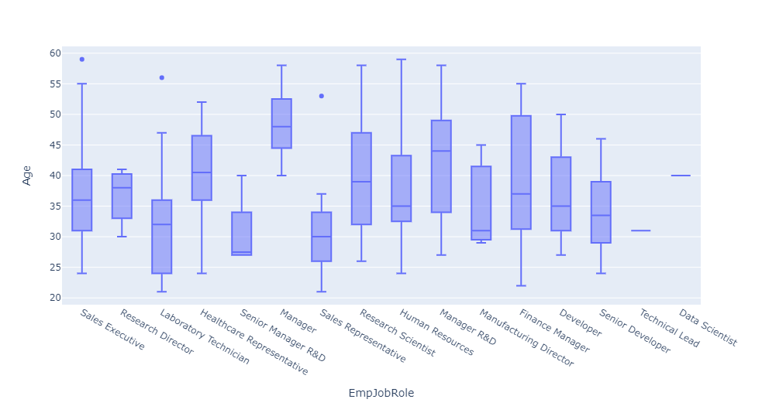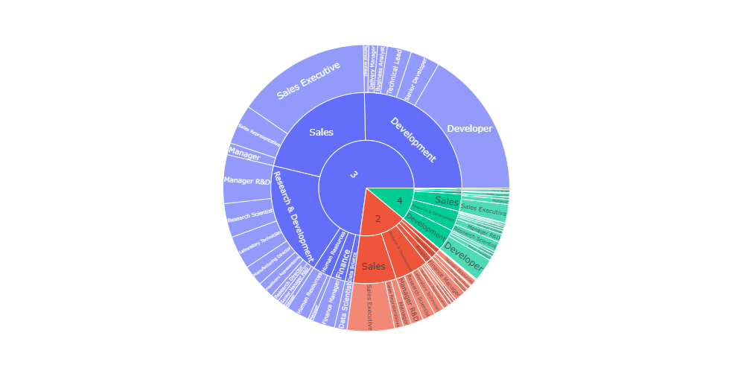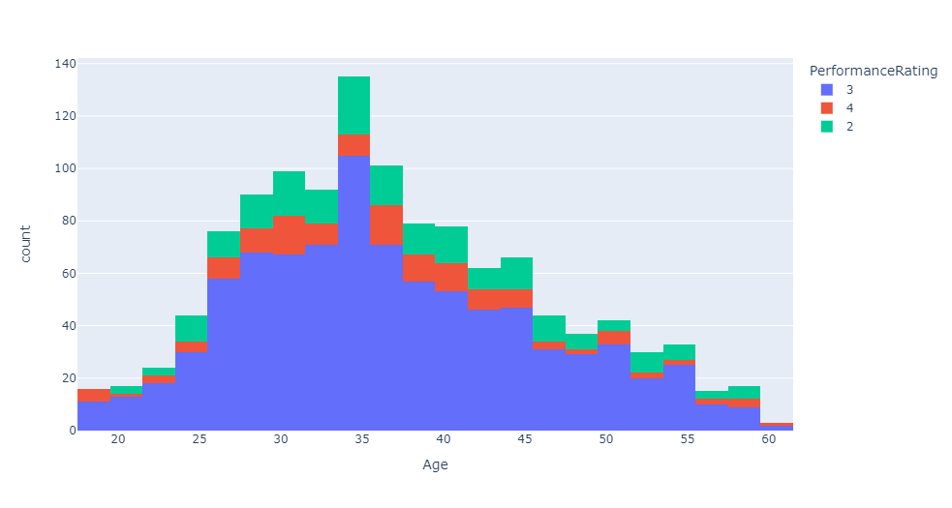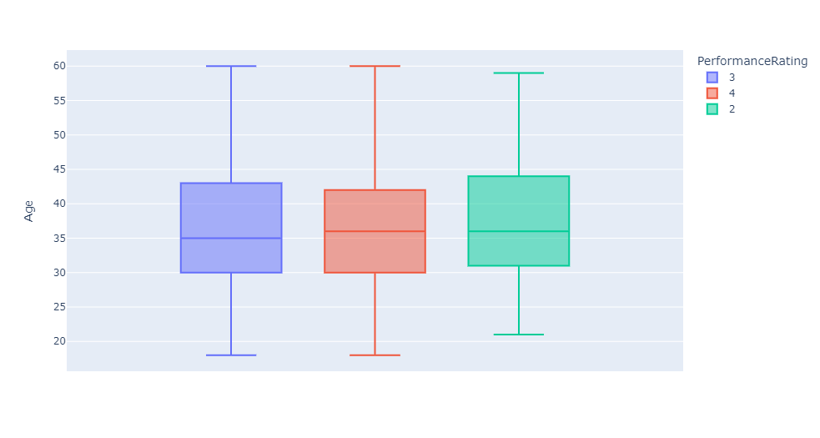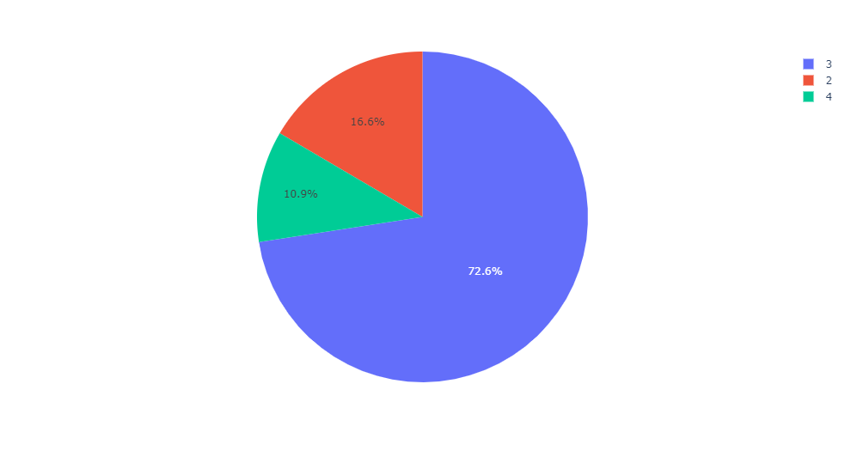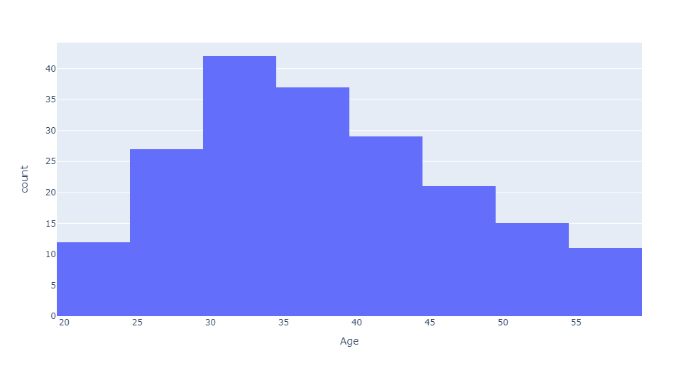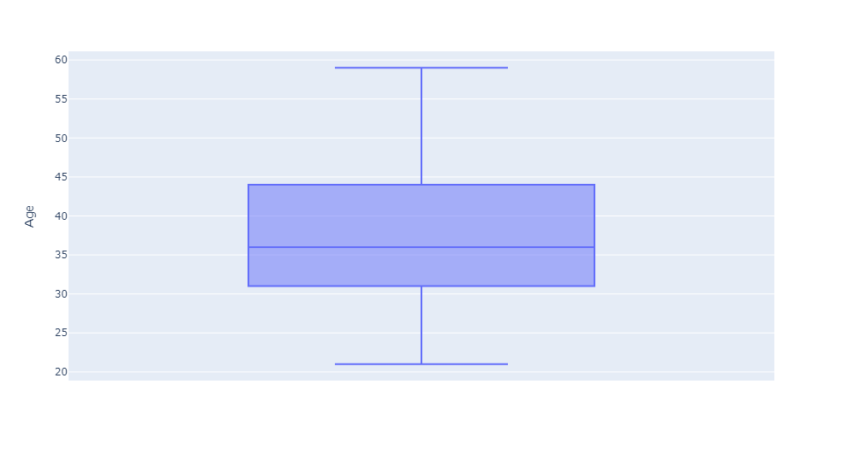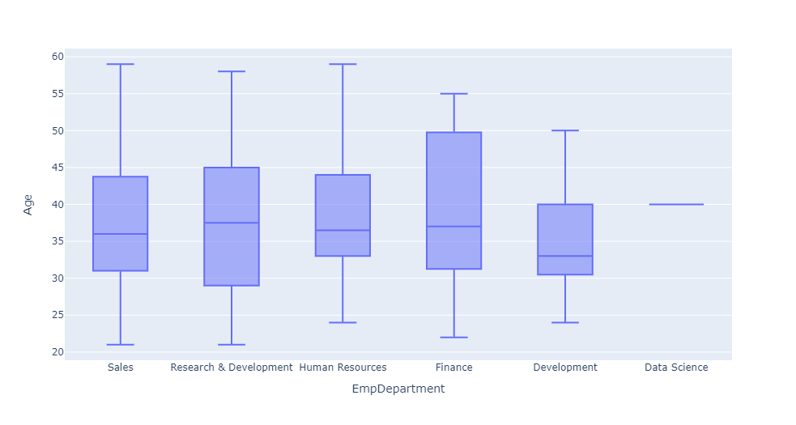

# Age for performance rating 2

# total of 194 employee are not working properly based on the given data set

# 39 people are between 20-29

# 108 people are between 30-44

# 36 people are between 45-54

# 11 people are between 55-59

# around 194 employees are not performing properly

# 87 Sales employees are not working

# 68 Research & Development

# 15 Finance

# 13 Development

# 10 Human Resources

# 1 Data Science

#compared to female sales employees male sales employees are not working properly

# Male employee not working properly with empjobrole >5

# Sales Executive 35

# Manager R&D 14

# Research Scientist 10

# Laboratory Technician 9

# Finance Manager 8

# Human Resources 8

# Sales Representative 7

# Healthcare Representative 6

# Manager 6

# Developer 5

# FeMale employee with empjobrole

# Sales Executive 29

# Finance Manager 7

# Research Scientist 7

# Manager 6

# Laboratory Technician 5

# Sales Representative 5

#From above plot its kind of negitive correlation ex: performance rating increases when the distancefromhome decreases